23. Develop a system using UML for Online Shopping System. This system should represent the shopping system as well as its primary users, and roles. The logs of the transactions should be carried out for the shopping. The cart should be maintained before the purchase transaction.

**Use Case Diagram :**

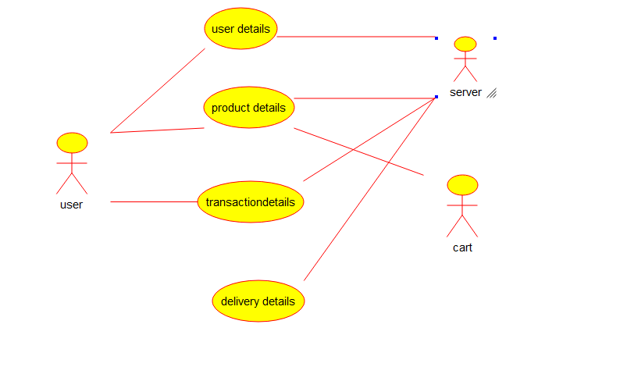

**Component Diagram :**

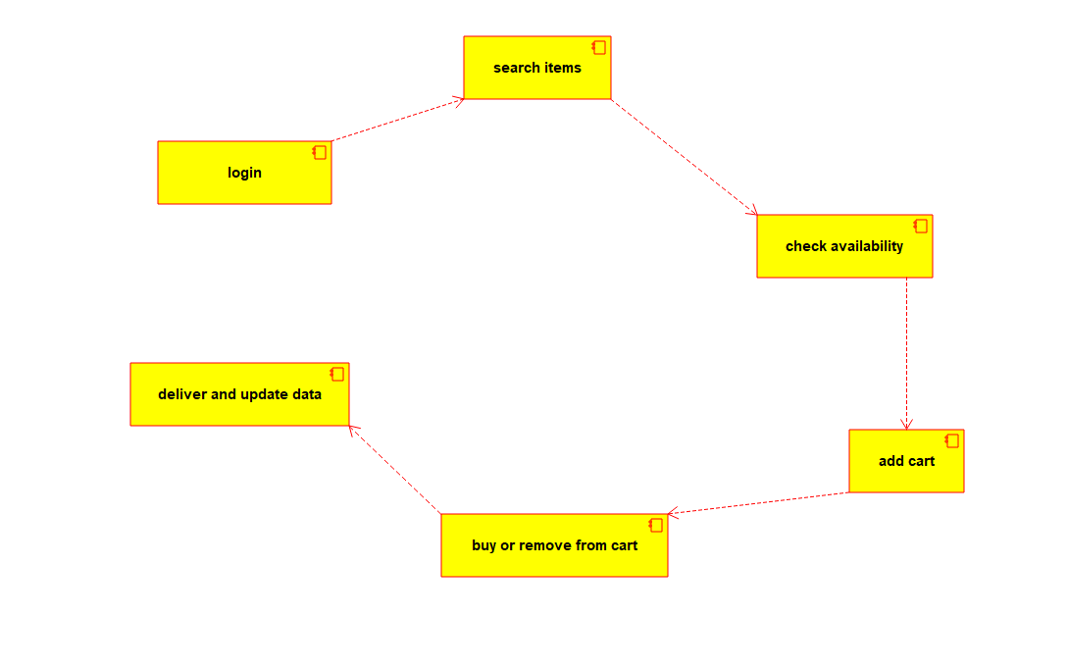

**Package Diagram :**

